Digital Egypt Pioneers Initiative (DEPI)
This graduation project was developed and implemented by:
1- Mahmoud Abdel-Majeed Abdel-Hay
2- Ihab Yousry Abu El-Yazid
3- Hoda Ahmed Abdel-Moneim
4- Sara Abdullah Zakaria
5- Eman Mostafa Shehata
Under the Supervision of:
Mr. Ramez Barakat

Creating a General Ledger Entry in Microsoft Dynamics 365
One of the most important parts of the system is the General Ledger, which is the main place where all financial transactions of the company are recorded.

In this example, we will create a journal entry for Electricity Expenses amounting to 10,000 in 02/01/2026 using the General Journal in the system.

1.Opening the Chart of Accounts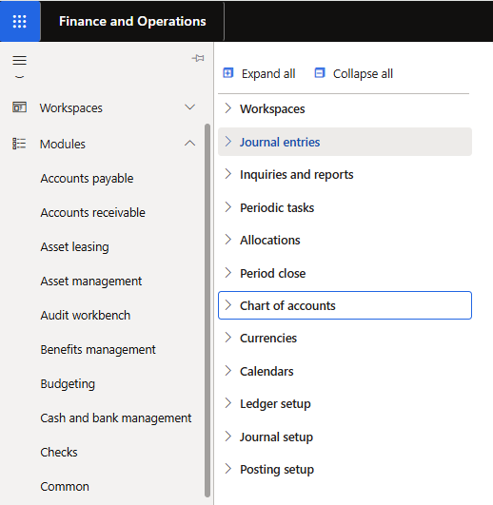
The Chart of Accounts contains all financial accounts used by the company, such as expense accounts, revenue accounts, assets, and liabilities.

Before recording any financial transaction, it is important to review the available accounts to make sure the correct account will be used.

Steps
1. From the Modules section in the system, select General Ledger.
2. Inside the General Ledger module, navigate to Journal Entries.
3. Click on Chart of Accounts.
4. The system will display a list of all ledger accounts available in the company.
5. This page allows users to review the accounts and identify the appropriate account that will be used in the journal entry.

After reviewing the accounts, the next step is to create a journal where the financial transaction will be recorded.
2.Opening the General Journals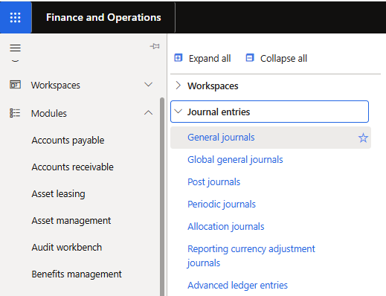
The General Journals page allows users to create journal batches where accounting entries are entered before posting them to the General Ledger.

Steps
1. From the General Ledger module, navigate to Journal Entries.
2. Select General Journals.
3. Choose the appropriate Journal Batch.
4. Open the journal to start entering the accounting transaction.

3.Creating the Journal Entry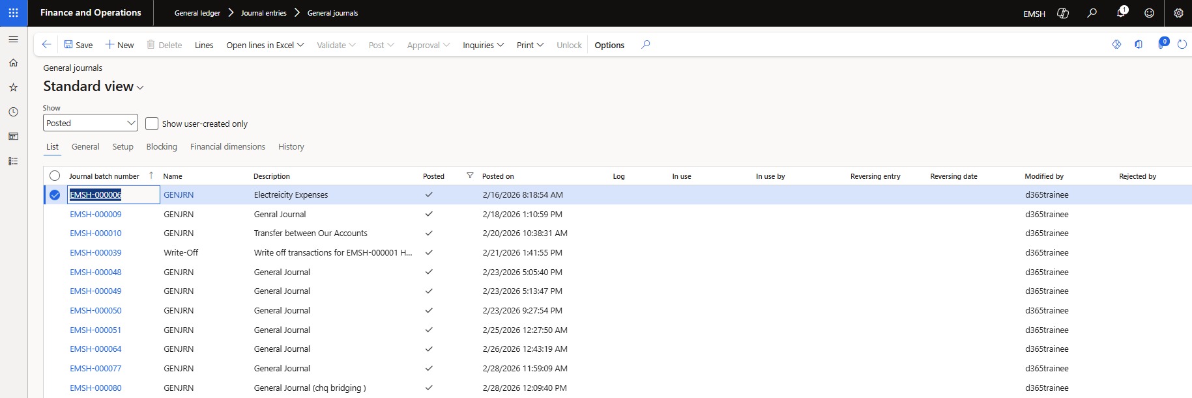
In this step, the electricity expense transaction is entered into the system using the journal lines.
Journal lines allow users to record the details of the financial transaction such as date, account, and amount.

Steps
1. Inside the selected General Journal, click on Lines.
2. A new page will open where the journal entry details can be entered.
3. Enter the following transaction information:
• Transaction Date: 02/01/2026
• Account: Electricity Expenses
• Debit Amount: 10,000
Add a description such as Electricity Expenses to clearly describe the transaction.
4.Posting the Journal Entry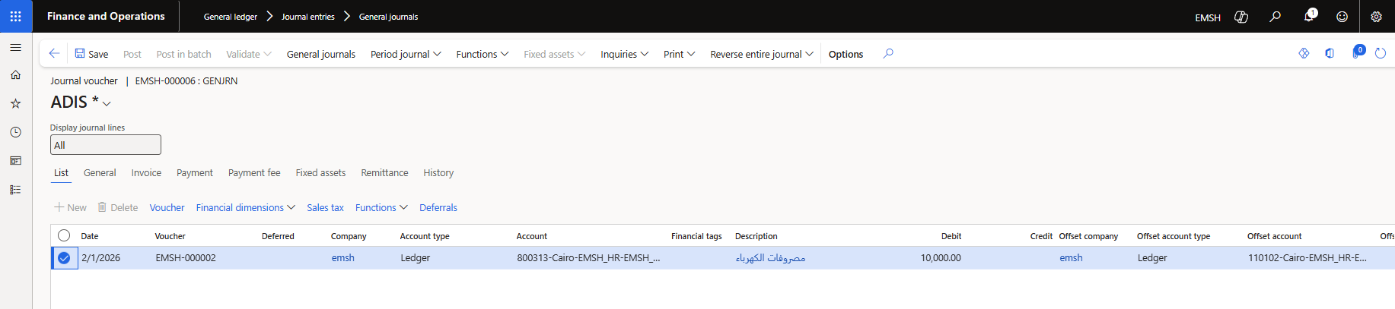
After entering the transaction details, the journal must be posted.
Posting the journal means that the transaction is confirmed and officially recorded in the General Ledger.

Steps
1. Review the journal entry details to ensure the information is correct.
2. Click Post from the action menu.
3. The system will process the transaction.
4. Once the posting process is completed, the electricity expense of 10,000 will be recorded in the company’s financial records.

Allocation Process in Microsoft Dynamics 365
Allocation is used in companies to divide shared expenses such as electricity or administrative costs across multiple accounts.

In this example, an expense amount of 10,000 is allocated across five accounts, where each account receives 20% of the total amount.

1. Create and activate Allocation Rule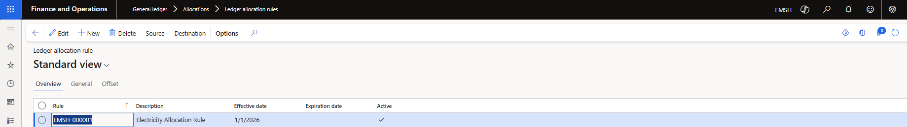 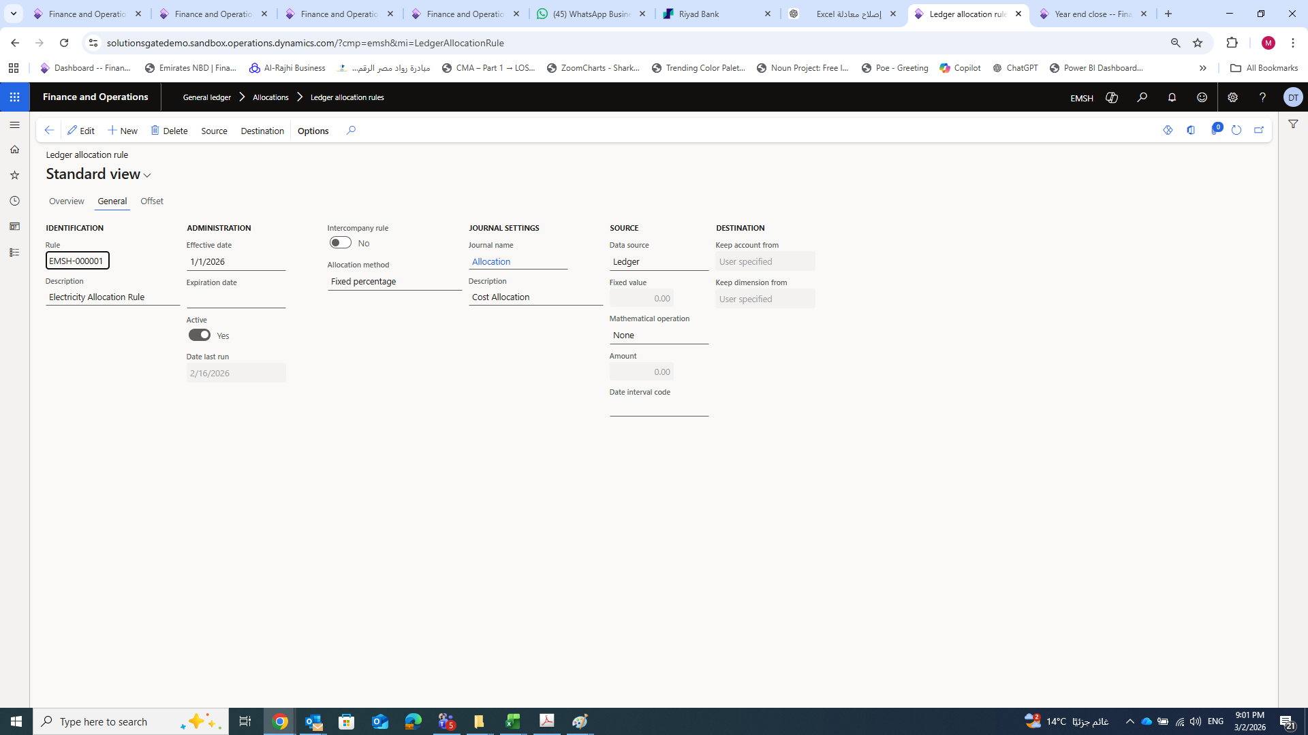
In this step, a new allocation rule is created to control how the expense amount will be distributed. The allocation rule must be activated before using it in the allocation process.

Steps
1. Go to General Ledger Module.
2. Select Allocations.
3. Choose Ledger Allocation Rules.
4. Create a new allocation rule.

5. Open the created allocation rule.
6. Click Activate.
2. Set Source and destination of Allocation Rule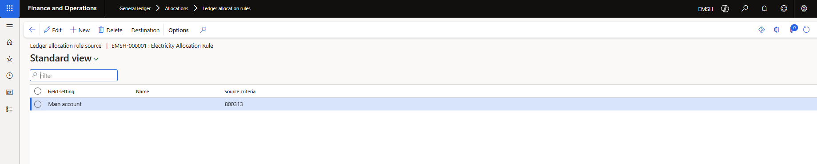 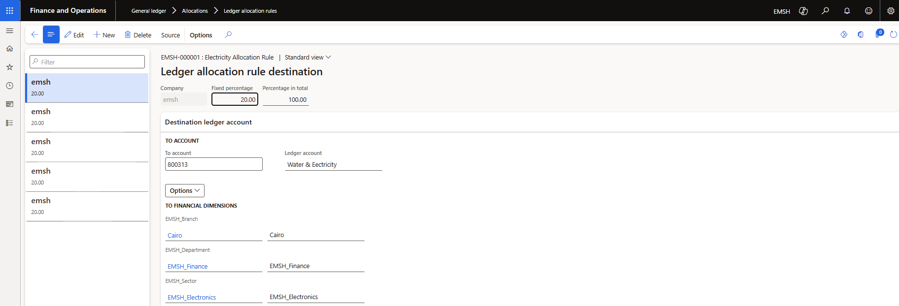
The Source account is the account from which the amount will be taken before distribution.
Steps
1. Open the Source settings inside the allocation rule.
2. Select the source expense account.
The Destination section defines the accounts that will receive the allocated amount.
In this example, the amount is distributed across five accounts, and each account receives 20% of the total amount.
Steps
1. Open Destination configuration.
2. Add the five destination accounts.
3. Set allocation percentage to 20% for each account.
3. Allocation Processing and Posting
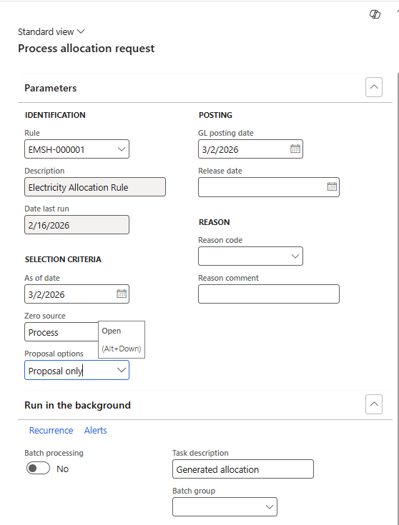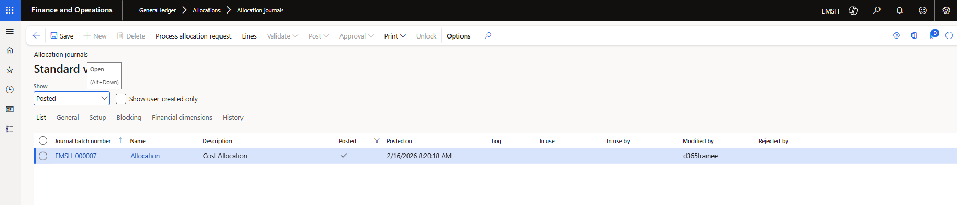
The allocation rule is processed to generate journal entries automatically.
The system distributes the expense amount (10,000) across the five accounts
After reviewing the generated journal entries, the transaction is posted.
Posting means that the allocation entry is officially recorded in the financial system.
4. Review of Allocation Journal Lines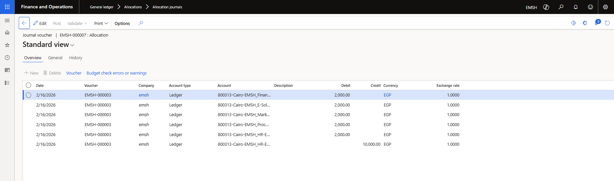

In the Standard View, the detailed journal lines generated by the allocation process can be reviewed.
• Total amount allocated = 10,000
• The amount is distributed across 5 accounts
• Each account receives 2,000
• Expense → 10,000
This completes the allocation process.

Periodic Journal Process in Microsoft Dynamics 365
Journal is used to save journal entry templates that can be reused later without entering the same financial data again.
It helps reduce repetitive work when recording similar transactions.
In this example, we will create a periodic journal entry and retrieve it from the system.

1. Create Periodic Journal
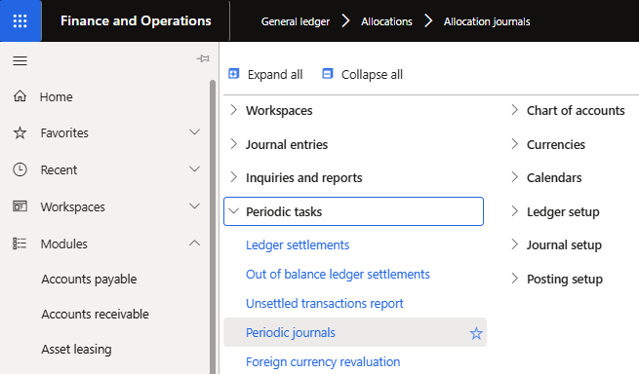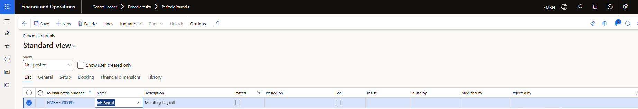
1. Go to General Ledger Module.
2. From the menu, select Periodic Tasks.
3. Click on Periodic Journal.
4. Click New to create a periodic journal.
5. Enter journal details if required.
6. Save the journal template.

This step allows the system to store reusable journal entries.
2. Enter Periodic Journal Lines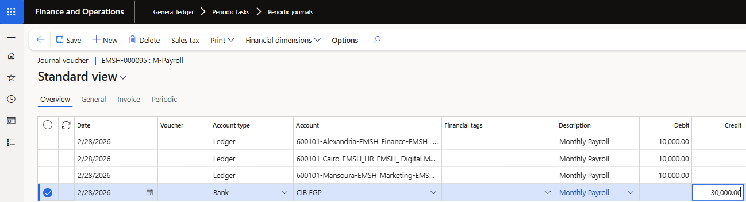
Steps
1. Open the created periodic journal.
2. Navigate to Journal Lines.
3. Enter transaction details if needed.

The journal entry template is now ready to be used.
3. Retrieve Periodic Journal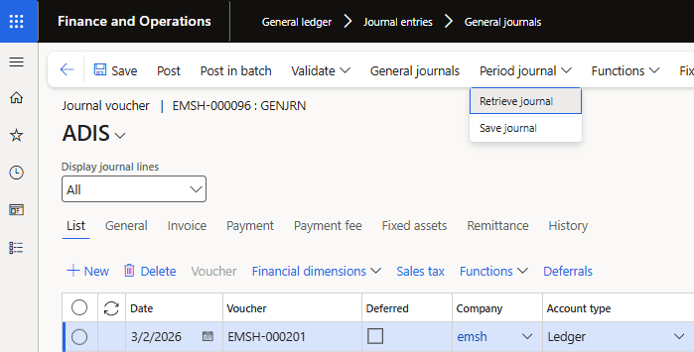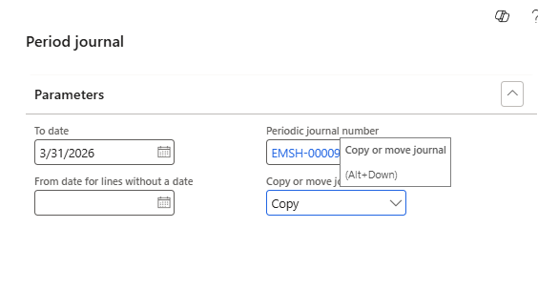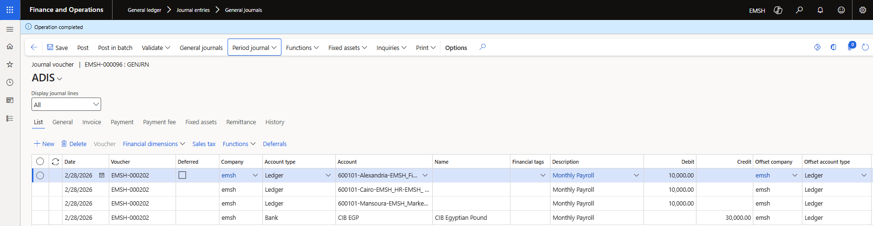
Steps
1.From general ledger go to general journal then from Periodic Journal Options
Select Retrieve Periodic Journal.
2. Choose the required journal template.
3. Review the retrieved entry.
This step allows users to reuse saved journal transactions.
After reviewing the journal entry details click Post to record the transaction in the system the journal entry will be saved in the General Ledger.

